STM32 PLC Pinouts
Innehållsförteckning
Pin definitions 1
LCD ILI9341 with SPI bus 5

Pin definitions
- CAN = CAN bus channel at 250 kB/s baud rate
- IC = Input capture pulse measurement
- Encoder = Encoder pulse measurement
- DADC = Differential Analog to Digital Converter
- ADC = Analog to Digital Converter
- DAC = Digital to Analog Converter
- PWR = Power supply
- PWM = Pulse with modulation
- DI = Digital input
Pin number | Iinput/Output | Name | Max voltage | Min voltage | Comment | Purpose
1 | Both | CAN High | 14V | -15V | TVS diodes for 30kV | CAN communication
2 | Both | CAN Low | 14V | -15V | TVS diodes for 30kV | CAN communication
3 | Input | IC 0 | 30V | -1V | 16 -bit resolution | Frequency 0 Hz to 10 kHz
4 | Input | IC 1 | 30V | -1V | 16 -bit resolution | Frequency 0 Hz to 10 kHz
5 | Input | IC 2 | 30V | -1V | 16 -bit resolution | Frequency 0 Hz to 10 kHz
6 | Input | IC 3 | 30V | -1V | 16 -bit resolution | Frequency 0 Hz to 10 kHz
7 | Input | Encoder 0 + | 30V | -1V | 16 -bit resolution | Counting  -32768 to 32767
8 | Input | Encoder 0 - | 30V | -1V | 16 -bit resolution | Counting  -32768 to 32767
9 | Input | Encoder 1 + | 30V | -1V | 16 -bit resolution | Counting  -32768 to 32767
10 | Input | Encoder 1 - | 30V | -1V | 16 -bit resolution | Counting  -32768 to 32767
11 | Input | Encoder 2 + | 30V | -1V | 16 -bit resolution | Counting  -32768 to 32767
12 | Input | Encoder 2 - | 30V | -1V | 16 -bit resolution | Counting  -32768 to 32767
13 | Input | DADC 4 - | 30V | -1V | PTC 30mA protection | Measuring -32768 to 32767
14 | Input | DADC 4 + | 30V | -1V | PTC 30mA protection | Measuring -32768 to 32767
15 | Input | DADC 3 - | 30V | -1V | PTC 30mA protection | Measuring -32768 to 32767
16 | Input | DADC 3 + | 30V | -1V | PTC 30mA protection | Measuring -32768 to 32767
17 | Input | DADC 2 - | 30V | -1V | PTC 30mA protection | Measuring -32768 to 32767
18 | Input | DADC 2 + | 30V | -1V | PTC 30mA protection | Measuring -32768 to 32767
19 | Input | DADC 1 - | 30V | -1V | PTC 30mA protection | Measuring -32768 to 32767
20 | Input | DADC 1 + | 30V | -1V | PTC 30mA protection | Measuring -32768 to 32767
21 | Input | DADC 0 - | 30V | -1V | PTC 30mA protection | Measuring -32768 to 32767
22 | Input | DADC 0 + | 30V | -1V | PTC 30mA protection | Measuring -32768 to 32767
23 | Input | ADC 11 | 30V | -1V | PTC 30mA protection | Measuring 0 to 65535
24 | Input | ADC 10 | 30V | -1V | PTC 30mA protection | Measuring 0 to 65535
25 | Input | ADC 9 | 30V | -1V | PTC 30mA protection | Measuring 0 to 65535
26 | Input | ADC 8 | 30V | -1V | PTC 30mA protection | Measuring 0 to 65535
27 | Input | ADC 7 | 30V | -1V | PTC 30mA protection | Measuring 0 to 65535
28 | Input | ADC 6 | 30V | -1V | PTC 30mA protection | Measuring 0 to 65535
29 | Input | ADC 5 | 30V | -1V | PTC 30mA protection | Measuring 0 to 65535
30 | Input | ADC 4 | 30V | -1V | PTC 30mA protection | Measuring 0 to 65535
31 | Input | ADC 3 | 30V | -1V | PTC 30mA protection | Measuring 0 to 65535
32 | Input | ADC 2 | 30V | -1V | PTC 30mA protection | Measuring 0 to 65535
33 | Input | ADC 1 | 30V | -1V | PTC 30mA protection | Measuring 0 to 65535
34 | Input | ADC 0 | 30V | -1V | PTC 30mA protection | Measuring 0 to 65535
35 | Output | DAC 2 | 30V | -1V | 12-bit resolution | 0 to 20mA output
36 | Output | DAC 1 | 30V | -1V | 12-bit resolution | 0 to 20mA output
37 | Output | DAC 0 | 30V | -1V | 12-bit resolution | 0 to 20mA output
38 | Input | VDC | 32V | -1V |  | Power supply for the 0 to 20 mA output
39 | Output | GND | 0V | 0V |  | Ground
40 | Input(Open drain) | PWM 7 | 30V | -1V | Use protection diode if solenoid is applied | MOSFET N-Channel PWM open drain
41 | Input(Open drain) | PWM 6 | 30V | -1V | Use protection diode if solenoid is applied | MOSFET N-Channel PWM open drain
42 | Input(Open drain) | PWM 5 | 30V | -1V | Use protection diode if solenoid is applied | MOSFET N-Channel PWM open drain
43 | Input(Open drain) | PWM 4 | 30V | -1V | Use protection diode if solenoid is applied | MOSFET N-Channel PWM open drain
44 | Input(Open drain) | PWM 3 | 30V | -1V | Use protection diode if solenoid is applied | MOSFET N-Channel PWM open drain
45 | Input(Open drain) | PWM 2 | 30V | -1V | Use protection diode if solenoid is applied | MOSFET N-Channel PWM open drain
46 | Input(Open drain) | PWM 1 | 30V | -1V | Use protection diode if solenoid is applied | MOSFET N-Channel PWM open drain
47 | Input(Open drain) | PWM 0 | 30V | -1V | Use protection diode if solenoid is applied | MOSFET N-Channel PWM open drain
48 | Input | DI 9 | 30V | -1V | Zener diode protection | Measuring 0 to 1
49 | Input | DI 8 | 30V | -1V |  | Measuring 0 to 1
50 | Input | DI 7 | 30V | -1V |  | Measuring 0 to 1
51 | Input | DI 6 | 30V | -1V |  | Measuring 0 to 1
52 | Input | DI 5 | 30V | -1V |  | Measuring 0 to 1
53 | Input | DI 4 | 30V | -1V |  | Measuring 0 to 1
54 | Input | DI 3 | 30V | -1V |  | Measuring 0 to 1
55 | Input | DI 2 | 30V | -1V |  | Measuring 0 to 1
56 | Input | DI 1 | 30V | -1V |  | Measuring 0 to 1
57 | Input | DI 0 | 30V | -1V |  | Measuring 0 to 1

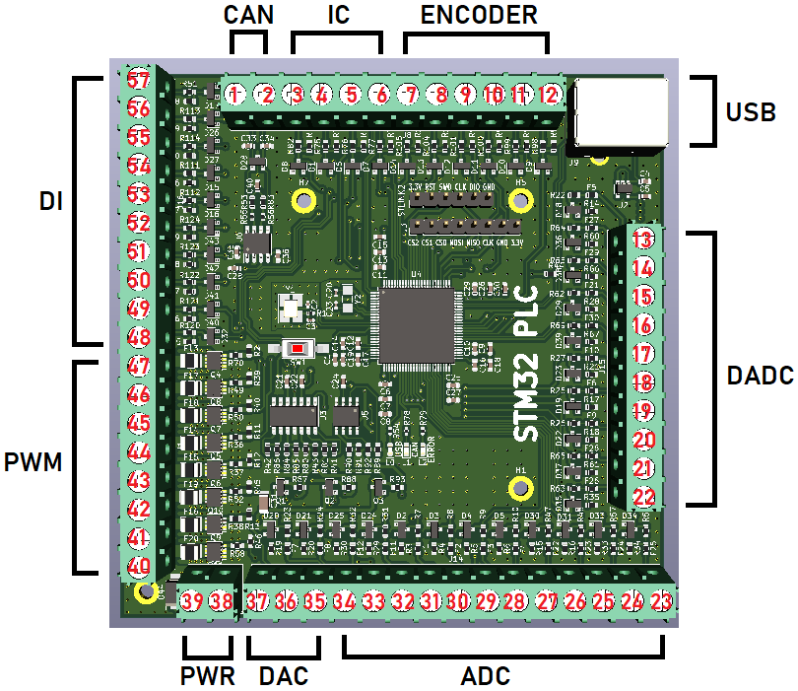
LCD ILI9341 with SPI bus
Notice that the CLK for the ST-LINK V2 and the other CLK pin is not the same! The other CLK pin is the SPI clock pin.

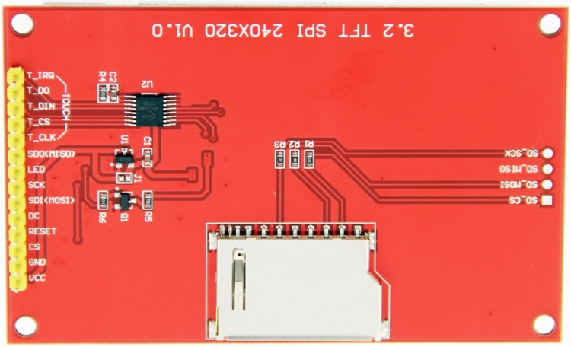
Connect | To | Comment
T_IRQ |  | Leave floating
T_DO | SDO<MISO> | On the LCD
D_DIN | SDI<MOSI> | On the LCD
T_CS | CS2 | On the STM32 PLC
T_CLK | SCK | On the LCD
SDO<MISO> | MISO | On the STM32 PLC
LED | VCC | On the LCD
SCK | CLK | On the STM32 PLC
SDI<MOSI> | MOSI | On the STM32 PLC
DC | CS1 | On the STM32 PLC
RESET | VCC | On the LCD
CS | CS0 | On the STM32 PLC
GND | GND | On the STM32 PLC
VCC | 3.3V | On the STM32 PLC

